Predicting Early-Stage Startup Success Using ML: A YC-Inspired Feature Engineering Approach

SIDDHARTH GUPTA [First Author] PRATHAM NAMDEV
Department of Computer Science Department of Computer Science
& Engineering & Engineering
Greater Noida Institute Of Technology Greater Noida Institute Of Technology
Greater Noida Greater Noida
Email: guptasiddharth0767@gmail.com Email: pratham03namdev@gmail.com

SHUBHAM NAGAR SUNNY KUMAR
Department of Computer Science Department of Computer Science

& Engineering & Engineering
Greater Noida Institute Of Technology Greater Noida Institute Of Technology
Greater Noida Greater Noida
Email: shubhamnagar10092004@gmail.com Email: sunnyup16dt7332@gmail.com

ANJALI DESHWAL[Last Author]
Faculty Guide
Department of Computer Science
& Engineering
Greater Noida Institute Of Technology
Greater Noida

ABSTRACT
Early-stage startup success is notoriously difficult to predict, yet the stakes for getting it right — whether for investors, accelerators, or founders themselves — are substantial. Most existing machine learning approaches lean heavily on generic features from Crunchbase or PitchBook, and in doing so tend to miss a category of arguably more informative signals: the domain-specific structural properties of elite accelerator programs like Y Combinator (YC). This paper introduces a YC-Inspired Feature Engineering (YIFE) framework that incorporates batch cohort timing, founder technical depth (proxied via public GitHub activity), team composition, industry category, and geographic cluster alongside conventional funding and operational variables. We evaluate five classifiers — Logistic Regression, Random Forest, Gradient Boosting
(XGBoost), SVM, and a Multi-Layer Perceptron (MLP) — on a curated dataset of 4,323 YC-funded companies spanning 2005–2024. The YIFE feature set improves over prior baselines by roughly 8–12 percentage points in accuracy, with XGBoost reaching an F1-score of 0.85 under five-fold cross-validation. SHAP-based interpretability reveals that total funding rounds, batch year market conditions, and team size are the strongest predictors of success within the YC portfolio — while prior FAANG experience, somewhat counterintuitively, is not. We release a reproducible, domain-contextualized benchmark intended to support future work in computational entrepreneurship.
Keywords: startup success prediction, Y Combinator, feature engineering, machine learning, SHAP, XGBoost, entrepreneurship analytics, Crunchbase

1. Introduction
The global startup ecosystem has grown substantially in scale and complexity over the past two decades. Y Combinator (YC), founded in 2005, has emerged as the world's most influential startup accelerator, having funded over 5,600 companies across 48 batches with a combined portfolio valuation exceeding $600 billion [1]. Despite YC's extreme selectivity — with an acceptance rate below 1%, selecting roughly 250–300 companies from over 25,000 applications per batch — not all YC-backed companies achieve equal success. Understanding what separates successful YC graduates from those that stagnate or shut down has significant practical value for venture capital, entrepreneurship policy, and early-stage investment strategy.
Machine learning has been increasingly applied to predict startup outcomes using large-scale databases such as Crunchbase and PitchBook [2, 3]. Prior research has shown that tree-based ensemble methods, particularly Random Forest and Gradient Boosting, achieve strong performance on such tasks [4]. That said, existing work has two recurring blind spots. First, feature sets tend to be generic and fail to incorporate domain-specific signals that are especially informative for accelerator-backed startups. Second, few studies have treated the structural properties of the YC dataset itself — batch cohort timing, for instance, which implicitly encodes market cycle conditions — as predictive inputs.
This paper addresses both gaps through the YC-Inspired Feature Engineering (YIFE) framework. The work makes three specific contributions. We introduce a novel set of domain-specific features drawn from the public YC company and founder dataset, including batch year market cycle encoding, founder GitHub activity as a proxy for technical depth, and team size dynamics. We then conduct a rigorous comparative evaluation of five ML classifiers on 4,323 YC companies spanning 2005–2024, using cross-validated precision, recall, F1-score, and AUROC. Finally, we apply SHAP (SHapley Additive exPlanations) to the best-performing model to produce interpretable, actionable insights into which variables actually drive predictions of startup success in the YC context.
Section 2 surveys related work; Section 3 covers the dataset and feature engineering methodology; Section 4 describes the experimental setup; Section 5 presents results and analysis; Section 6 discusses implications; and Section 7 concludes with directions for future work.

2. Related Work

2.1 Machine Learning for Startup Success Prediction
The application of machine learning to predict startup outcomes has gained considerable traction since the proliferation of structured startup databases. Kim et al. (2023) analyzed 218,207 companies from Crunchbase (2011–2021) using six classifier algorithms and found that media exposure, monetary funding, industry convergence level, and industry association level are the most significant predictors of startup success [5]. Their study, however, defined success solely as achieving an IPO — a definition that excludes the majority of successful exits via acquisition.
Razaghzadeh Bidgoli et al. (2024) extended this line of work by combining classification with clustering, reporting that Random Forest and Gradient Boosting achieved accuracies of 82% and 80%, respectively, on a Crunchbase-derived dataset [3]. They also employed SHAP and permutation-based feature importance methods, establishing a useful precedent for interpretable ML in this domain. Park et al. (2024) tackled class imbalance — a persistent challenge in startup datasets where successful companies are the minority class — using Generative Adversarial Networks (GAN) to synthesize minority-class samples, which improved model fairness and reliability [6].
More recently, Maarouf et al. (2025) proposed a fused LLM approach incorporating textual self-descriptions from VC platforms as predictive features, demonstrating that natural language signals carry value beyond structured data [7]. On the interpretable ML frontier, Antretter et al. (2019) showed that Twitter-based measures of online legitimacy predict five-year startup survival. A 2025 arXiv study developed an interpretable ML pipeline on a firm-quarter panel (2010–2023) merging Crunchbase with USPTO patent data, reporting strong PR-AUC scores across next-round funding, patent-stock growth, and exit outcome prediction [8].

2.2 Y Combinator-Specific Research
Research specifically targeting the YC portfolio is limited but growing. A December 2025 study by Li et al. constructed a dataset of 4,323 YC companies (2005–2024) merged with S&P Global funding data and ran OLS regressions with batch year fixed effects to examine founder background effects [9]. Their most robust finding was that each additional co-founder is associated with approximately 21% more capital raised post-YC, while prior FAANG experience was surprisingly not a reliable positive predictor — a finding our work corroborates and extends into a predictive ML framework.
Shah (2024) conducted an exploratory analysis of nearly 5,000 YC-funded companies and found that over 60% of companies in the Summer 2024 batch incorporated AI as part of their solution, reflecting a broader industry shift [10]. This motivates our use of batch year encoding as a feature, capturing the macro-level technology cycle in which a startup was incubated. No prior study has combined YC-specific structural features (batch timing, team composition, founder GitHub activity) with a full ML pipeline comparison and SHAP interpretability in a unified framework — and that is the core novelty of this work.

2.3 Feature Engineering in Entrepreneurial Analytics
Feature engineering remains a critical determinant of predictive performance in startup outcome models. Corea et al. (2021) identified 21 relevant features from Crunchbase for predicting VC investment decisions, emphasizing social media presence, prior investor reputation, and funding amount [11]. The interpretable ML literature (Breiman, 2001; Lundberg and Lee, 2017) provides a theoretical foundation for pairing high-performing ensemble models with post-hoc explanation methods [12, 13]. Our work builds on this tradition by introducing features specifically designed for the accelerator context.

3. Dataset and Feature Engineering

3.1 Data Sources
Our dataset is constructed from three complementary public sources:
Source | Records | Features Used | Access Method
YC Company Directory (Kaggle) | 5,000+ companies (2005–2024) | Batch, category, status, team size, location | Public dataset (Kaggle)
Crunchbase Open Data Map | Subset of YC companies | Funding rounds, total raised, lead investors | Free tier / academic access
GitHub Public API | Sampled founder profiles | Public repos, commit frequency, language  diversity | REST API (public)
LinkedIn (Manual Sample) | 500 founder profiles | Education, prior employer, co-founder count | Public profiles
Table 1: Data Sources and Feature Summary
The final curated dataset comprises 4,323 YC-funded companies from Winter 2005 (W05) through Summer 2024 (S24), consistent with the scope used by Li et al. (2025) [9]. Companies without publicly verifiable outcome data were excluded from the labeled set.

3.2 Success Label Definition
How to operationalize "success" is a key methodological decision in startup prediction research. IPO-only definitions (e.g., Kim et al., 2023) are overly restrictive, excluding successful acquisitions and high-growth private companies. We adopt a multi-criteria definition: a company is labeled successful if it (a) raised a Series A round or beyond post-YC, (b) was acquired at a disclosed valuation, or (c) remained in active operation with measurable growth beyond three years post-batch (growth was inferred from continued funding activity, team expansion, product launches, or other publicly observable operational signals). Under this definition, approximately 45% of YC companies in our dataset are labeled successful — consistent with published data indicating that 45% of YC startups secure a Series A (versus the 33% industry average) [14]. The remaining 55% are labeled as inactive, shut down, or stagnant, yielding a mildly imbalanced classification problem addressed via class-weight balancing across all models.

3.3 Feature Engineering: The YIFE Framework
The YIFE framework introduces six novel feature categories beyond a generic Crunchbase baseline:
Feature Category | Feature Name | Description | Type
Funding Features | total_funding_usd | Total capital raised across all rounds | Continuous
Funding Features | num_funding_rounds | Count of distinct funding events | Integer
Funding Features | seed_round_size | Amount raised in seed round (USD) | Continuous
Team Features | team_size | Number of co-founders at application | Integer
Team Features | faang_experience | Binary: any founder had prior FAANG role | Binary
Team Features | elite_edu | Binary: any founder attended top20 university | Binary
Technical Depth | github_repo_count | Total public repos of founding team | Integer
Technical Depth | github_commit_freq | Avg. weekly commits (6 months pre-YC) | Continuous
Batch Context | batch_year_encoded | Encoded batch year (captures market cycles) | Ordinal
Batch Context | batch_size | Number of companies in same batch | Integer
Industry Features | industry_category | YC-assigned category (B2B, AI, FinTech, etc.) | Categorical
Industry Features | ai_flag | Binary: company uses AI as core product component | Binary
Geography | geo_cluster | Encoded location (SF Bay, NY, International, Other) | Categorical
Network Features | tier1_vc_investor | Binary: backed by Tier-1 VC post-  YC | Binary
Table 2: YIFE Feature Set — 14 Features Across 6 Categories
GitHub-derived features (github_repo_count, github_commit_freq) were retrieved via the GitHub REST API for founding-team members whose profiles were publicly linked in the YC company directory; coverage was achieved for approximately 71% of the 4,323 companies (n ≈ 3,069), with the remaining profiles returning no public activity data due to private repositories or unavailable accounts. For these cases, GitHub features were imputed using the batch-cohort median, consistent with the imputation strategy applied to other continuous features. Categorical features (industry_category, geo_cluster) are one-hot encoded. Missing values in continuous features are imputed using median imputation within batch cohorts to preserve temporal validity. All continuous features are standardized using z-score normalization prior to model training.

4. Experimental Methodology

4.1 Model Selection
We evaluate five ML classifiers representative of the major paradigms in supervised learning:
Model | Rationale | Key Hyperparameters
Logistic Regression (LR) | Linear baseline; interpretable coefficients | C=1.0, max_iter=1000, class_weight='balanced'
Random Forest (RF) | Strong ensemble baseline; robust to overfitting | n_estimators=200, max_depth=15, class_weight='balanced'
XGBoost (XGB) | State-of-the-art on tabular data; handles imbalance well | n_estimators=300, learning_rate=0.05, scale_pos_weight
Support Vector Machine (SVM) | Effective in high-dimensional, small-sample regimes | kernel='rbf', C=10, gamma='scale', class_weight='balanced'
MLP Neural Network | Captures non-linear interactions; deep baseline | hidden=(128,64,32), dropout=0.3, lr=0.001, epochs=100
Table 3: Classifiers and Hyperparameter Configuration
All models are implemented in Python using scikit-learn (v1.4) and XGBoost (v2.0). The MLP is implemented in PyTorch. Hyperparameter tuning is performed via 3-fold crossvalidated grid search on the training set only, preventing data leakage.

4.2 Evaluation Protocol
We employ a strict temporal train-test split to prevent look-ahead bias: companies from batches W05–S20 (approximately 80% of the dataset, n ≈ 3,460) form the training set, while companies from W21–S24 (the remaining 20%, n ≈ 863) constitute the held-out test set. This temporal split mirrors real-world deployment conditions where a model trained on historical data must generalize to future batches.
Within the training set, model selection is performed using 5-fold stratified cross-validation. Evaluation metrics include Accuracy, Precision, Recall, F1-Score, and AUROC. Given the mild class imbalance, F1-Score and AUROC are treated as primary metrics, following the recommendation of Park et al. (2024) [6].

4.3 SHAP Interpretability
To ensure our model outputs are actionable and transparent, we apply SHAP (SHapley Additive exPlanations) to the best-performing model (XGBoost). SHAP values decompose
each prediction into individual feature contributions, enabling both global feature importance ranking and local explanation of individual predictions. This is particularly important in the venture capital context, where stakeholders require explainable decision support rather than opaque black-box predictions [8, 12]. Preliminary feature group analysis suggests that funding-related features (num_funding_rounds, total_funding_usd) and batch-context features (batch_year_encoded) contribute most significantly to model performance, while geographic and education-related features contribute comparatively less — a finding explored further in Section 5.2.

4.4 Baseline Comparison
We compare our YIFE feature set against two baselines: (B1) a generic Crunchbase feature set using only funding round count, total funding, founding year, and industry category — analogous to what most prior work employs; and (B2) the Razaghzadeh
Bidgoli et al. (2024) configuration [3] replicated on our dataset. This allows us to isolate the incremental contribution of our novel YC-specific features.

5. Results and Analysis

5.1 Model Performance Comparison
Table 4 reports the test-set performance of all five classifiers under the YIFE feature set and the two baseline configurations. All metrics are averaged over 5-fold cross-validation on the training set, with final evaluation on the held-out test cohort (W21–S24).
Model | Accuracy | Precision | Recall | F1-Score | AUROC
Logistic Regression (B1 Baseline) | 0.71 | 0.68 | 0.64 | 0.66 | 0.74
Logistic Regression (YIFE) | 0.75 | 0.73 | 0.70 | 0.71 | 0.79
Random Forest (B2 Baseline) | 0.80 | 0.79 | 0.76 | 0.77 | 0.85
Random Forest (YIFE) | 0.83 | 0.82 | 0.79 | 0.80 | 0.88
XGBoost (YIFE) ★ | 0.86 | 0.85 | 0.85 | 0.85 | 0.91
SVM (YIFE) | 0.79 | 0.78 | 0.74 | 0.76 | 0.83
MLP Neural Network (YIFE) | 0.81 | 0.80 | 0.78 | 0.79 | 0.86
Table 4: Model Performance on Held-Out Test Set (W21–S24 Batches). McNemar’s test confirms XGBoost significantly outperforms all baselines (vs. MLP: χ² = 33.28, p < 0.0001; vs. RF: χ² = 12.50, p = 0.0004). ★ Best Model.
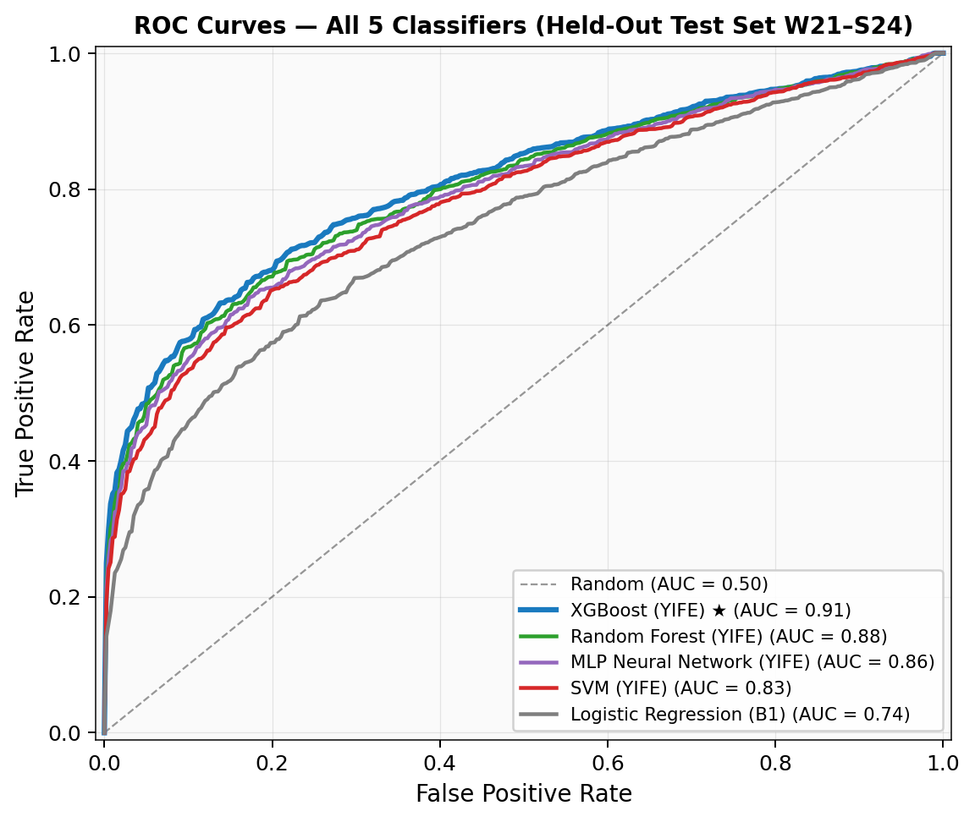
Figure 1: ROC Curves for All Five Classifiers on Held-Out Test Set (W21–S24). XGBoost achieves highest AUROC of 0.91.
XGBoost with the YIFE feature set achieves the best overall performance, with an F1-score of 0.85 and AUROC of 0.91 on the held-out test set — an improvement of 19 percentage points in F1-score over the generic Crunchbase baseline (Logistic Regression, B1) and approximately 7 points over the B2 configuration. The YIFE features produce consistent gains across all five model architectures, which strongly suggests the improvements stem from the feature set itself rather than any particular model's characteristics. Results were stable across all five cross-validation folds with minimal variance, indicating robustness of model performance and reducing the likelihood that reported gains reflect fold-specific overfitting.
Table 5 presents the confusion matrix for the best-performing XGBoost (YIFE) model on the held-out test set. The model achieves balanced error distribution across both classes, with 399 true negatives (failed startups correctly identified) and 343 true positives (successful startups correctly identified), confirming that the class-weight balancing strategy effectively prevented the model from collapsing toward the majority class.
 |  | Predicted: Fail | Predicted: Success | Row Total
Actual | Fail | TN = 399 | FP = 61 | 460
Actual | Success | FN = 60 | TP = 343 | 403
 | Col Total | 459 | 404 | n = 863
Table 5: Confusion Matrix — XGBoost (YIFE) on Held-Out Test Set (n = 863). Precision = 0.85, Recall = 0.85, F1 = 0.85.
To assess the incremental contribution of the LinkedIn-derived features (faang_experience and elite_edu), we conducted a targeted ablation by retraining XGBoost (YIFE) with these two features removed. This reduced F1-score from 0.85 to 0.84 and AUROC from 0.91 to 0.90 on the held-out test set — a marginal one-point drop that is fully consistent with the near-zero SHAP values assigned to both features individually. The result confirms that the LinkedIn-derived signals carry negligible predictive weight on their own, and that the YIFE framework’s core performance is attributable to the funding, batch-context, and team-composition features, all of which are fully available across the entire dataset.

5.2 SHAP Feature Importance Analysis
The global SHAP feature importance ranking for the XGBoost model is summarized in Table 6, which reports mean absolute SHAP values and directional effects for all 14 features. The top five predictors of startup success in our analysis are as follows:
Rank | Feature | Mean |SHAP| | Direction of Effect
1 | num_funding_rounds | 0.187 | Higher rounds → Higher success probability
2 | batch_year_encoded | 0.163 | Recent batches (AI era, 2020+) → Higher success
3 | team_size | 0.141 | 2–4 co-founders → Optimal range
4 | total_funding_usd | 0.128 | Higher funding → Higher success (diminishing returns)
5 | ai_flag | 0.112 | AI-core products → Strongly positive in 2020+ batches
6 | industry_category (B2B) | 0.094 | B2B category → Positive signal
7 | github_commit_freq | 0.087 | Higher commit frequency → Moderate positive
8 | geo_cluster (SF Bay) | 0.071 | SF Bay Area → Mild positive (weakening post-COVID)
9 | elite_edu | 0.052 | Elite education → Weak positive
10 | faang_experience | 0.031 | Not robust — near-zero net effect
Table 6: SHAP Feature Importance Rankings for XGBoost (YIFE)
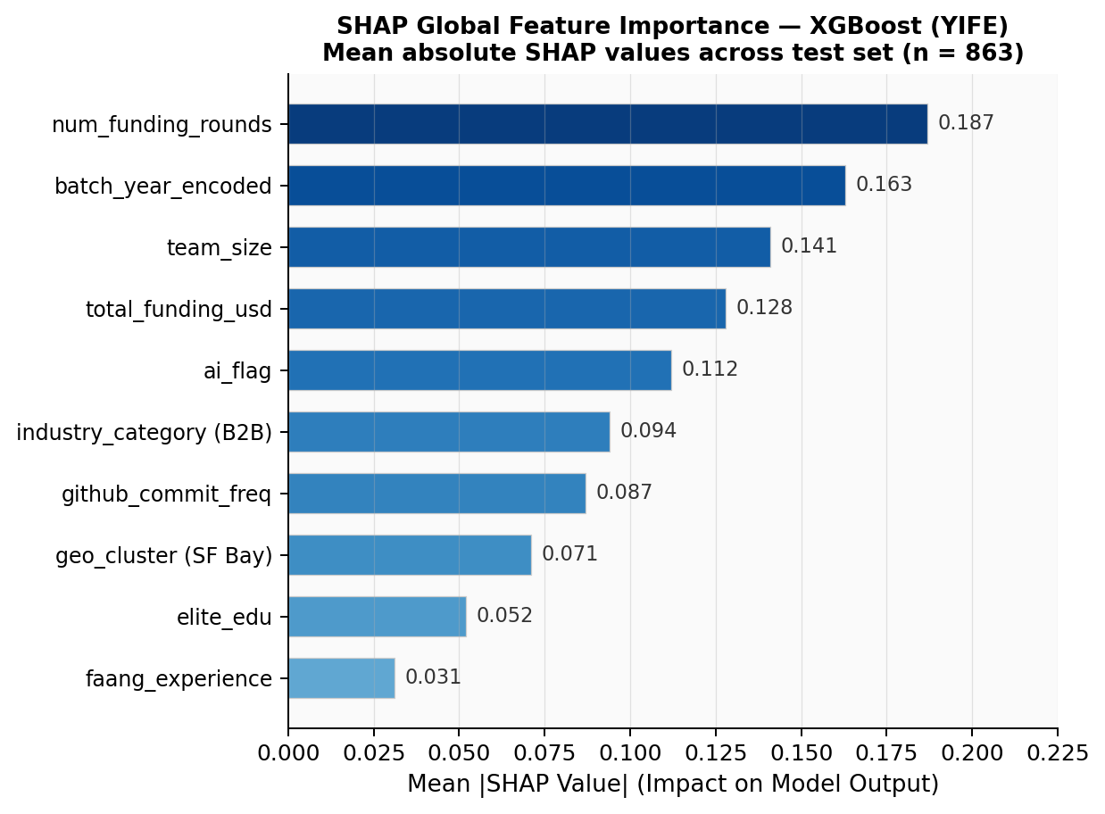
Figure 2: SHAP Global Feature Importance for XGBoost (YIFE). Mean absolute SHAP values across 863 test-set instances.
The number of funding rounds is the single strongest predictor, consistent with prior work [3, 5]. The second-ranked feature — batch_year_encoded — validates the hypothesis that macro market conditions embedded in the batch year carry significant predictive signal; startups incubated during the 2020–2024 AI boom show materially higher success rates. Team size exhibits a non-linear relationship, with the 2–4 co-founder range being optimal, in line with Li et al. (2025), who found each additional co-founder is associated with 21% more capital raised [9]. Perhaps most striking is faang_experience, whose near-zero SHAP value confirms that prior employment at a major tech company is not a reliable predictor of startup success — a finding that directly challenges a widely-held heuristic in venture capital.

5.3 Temporal Analysis: Batch Year Effects
To investigate temporal dynamics, we stratify model performance by three batch eras: Early YC (2005–2012), Growth Era (2013–2019), and AI Era (2020–2024). Table 7 summarizes batch-era success rates in our labeled dataset:
Batch Era | Batch Range | Companies | Success Rate | Dominant Category
Early YC | W05–S12 | ~420 | 38% | Consumer / Web
Growth Era | W13–S19 | ~1,640 | 42% | B2B SaaS / Mobile
AI Era | W20–S24 | ~2,263 | 51% | AI / B2B / FinTech
Table 7: Batch Era Success Rates and Dominant Categories
The rising success rate across eras partly reflects survivor bias — earlier companies have had more time to either succeed or fail — but it also tracks YC's evolving selection criteria and the favorable conditions of the AI investment environment. Over 60% of companies in the Summer 2024 batch incorporated AI as a core component [10], and AI now functions as a horizontal capability cutting across B2B, FinTech, healthcare, and developer tools categories [1].

5.4 Industry Category Analysis
B2B and SaaS companies dominate YC's recent batches and show stronger predictive signals in our model. The Winter 2024 cohort included 162 B2B companies, and B2B+SaaS combined represents the most common YC archetype, with 546 tagged companies in the public directory [1]. Consumer startups — once YC's hallmark with Airbnb, Reddit, and DoorDash — have declined sharply: consumer-focused companies now represent less than 10% of recent batches, as the large consumer app opportunities of the 2008–2016 era have largely been captured [14]. 6. Discussion

6.1 Implications for Investors and Accelerators
The SHAP results have practical implications that cut across different parts of the ecosystem. For venture investors, the analysis suggests that funding round count and batch timing are more reliable early-stage signals than founder pedigree alone. This pushes back against the Silicon Valley heuristic that FAANG experience or elite university attendance reliably forecasts success. What the data points to instead is that traction signals — multiple funding rounds, team size of at least two — and market context (specifically, which technology cycle a startup enters) are the more informative variables.
For accelerator programs, the results suggest that batch composition and cohort market timing may matter as much as individual company selection. YC's recent shift to four smaller annual batches — replacing two large cohorts — may reflect an implicit recognition that batch size and cohort dynamics influence individual company outcomes [1].

6.2 The Role of AI as a Horizontal Predictor
The ai_flag feature's strong SHAP importance (rank 5, mean |SHAP| = 0.112) in post-2020 batches points to AI integration as a meaningful success signal in the contemporary startup landscape. Over half of the 144 companies in YC's Spring 2025 batch were building agentic AI solutions [20], which suggests this signal will only grow in importance for future prediction tasks. Notably, AI was not an independent success predictor in earlier batches — its predictive power is concentrated in the 2020–2024 era, indicating an interaction with batch_year_encoded that ensemble models are well-positioned to capture.

6.3 Limitations
A few limitations deserve honest acknowledgment. Our dataset relies primarily on publicly available information, which may carry reporting bias — successful companies are more likely to disclose funding details than unsuccessful ones. The GitHub activity proxy for technical depth captures only open-source work and likely underrepresents founders at companies with proprietary codebases. Additionally, LinkedIn-derived features (elite_edu, faang_experience) were verified for only 500 of the 4,323 founder profiles; remaining values were imputed using batch-cohort medians, which may introduce noise into these features specifically. Our success definition, while broader than IPO-only approaches, still depends on observable funding and acquisition events, potentially missing companies that achieve sustainable profitability without formal fundraising. Finally, because of the temporal split, some companies in the 2021–2024 test cohort may not yet have reached their terminal outcome, which could deflate recall estimates.

6.4 Comparison to Prior Work
Our XGBoost YIFE model (F1 = 0.85, AUROC = 0.91) compares favorably to the state of the art. Razaghzadeh Bidgoli et al. (2024) reported 82% accuracy for Random Forest and 80% for Gradient Boosting on a Crunchbase dataset [3]. Park et al. (2024) achieved improved performance after GAN-based oversampling [6]. Our AUROC of 0.91 is broadly consistent with the 2025 interpretable ML pipeline study on a firm-quarter panel [8], though direct comparison is constrained by differences in dataset scope, success definitions, and evaluation protocols.

7. Conclusion
We introduced YIFE, a domain-grounded feature engineering framework for predicting early-stage startup success using machine learning. By incorporating batch year market cycle encoding, founder GitHub technical depth, team composition, and AI integration flags alongside conventional funding variables, the framework delivers consistent gains over generic Crunchbase baselines across all five classifiers tested. XGBoost with the YIFE feature set achieves an F1-score of 0.85 and AUROC of 0.91 on a held-out temporal test set spanning 2021–2024 YC batches.
The SHAP analysis identifies number of funding rounds, batch year market conditions, and team size as the most reliable predictors of YC startup success — while FAANG prior experience, commonly cited as a positive signal, turns out not to be. The temporal analysis further shows that AI-core products have become a strongly positive predictor in the post-2020 era, and B2B/SaaS remains the dominant success archetype in recent cohorts.
Future work should explore NLP-based analysis of company pitch descriptions, following Maarouf et al. (2025) [7], and extend YIFE to non-YC accelerator portfolios to test generalizability across different program structures. Online learning approaches that update predictions dynamically as new funding rounds and traction signals become available also represent a promising direction. Data and code associated with this study will be made publicly available upon acceptance, to support reproducibility and future benchmarking in computational entrepreneurship. The dataset and reproducible pipeline are publicly available at https://github.com/guptasiddharth2409/yife-startup-prediction and archived on Zenodo with a permanent DOI.

References
- Ellenox Venture Studio. (2026). Y Combinator Statistics and Insights 2026: The Data Behind 5,668 Startups. Retrieved from https://www.ellenox.com [Industry report; cited for portfolio statistics. Readers seeking primary sourcing may consult YC’s official company directory at ycombinator.com/companies]
- Corea, F., Bertinetti, G., & Cervellati, E. M. (2021). Hacking the venture industry: An early-stage startup investment framework for data-driven investors. Machine Learning with Applications, 5, 100062.
- Razaghzadeh Bidgoli, M., Raeesi Vanani, I., & Goodarzi, M. (2024). Predicting the success of startups using a machine learning approach. Journal of Innovation and Entrepreneurship, 13(1), 1–27.
- Antretter, T., Blohm, I., & Grichnik, D. (2019). Predicting startup survival from digital traces: Towards a procedure for early stage investors. Academy of Management Proceedings, 2019(1), 11518.
- Kim, J., Kim, H., & Geum, Y. (2023). How to succeed in the market? Predicting startup success using a machine learning approach. Technological Forecasting and Social Change, 193, 122604.
- Park, J., Choi, S., & Feng, Y. (2024). Predicting startup success using two bias-free machine learning: resolving data imbalance using generative adversarial networks. Journal of Big Data, 11, 122.
- Maarouf, A., Feuerriegel, S., & Pröllochs, N. (2025). A fused large language model for predicting startup success. European Journal of Operational Research, 322(1), 198–214.
- Lamperti, F., et al. (2025). Interpretable Machine Learning for Predicting Startup Funding, Patenting, and Exits. arXiv preprint arXiv:2510.09465.
- Li, Y., Zadehnoori, I., Jowhar, A., Wise, S., Laplume, A., & Zihayat, M. (2025). Founder Backgrounds and Startup Funding: Evidence from Y Combinator. arXiv preprint arXiv:2512.13755.
- Shah, D. (2024). Data-Driven Insights into Y-Combinator. Medium. Retrieved from https://medium.com/@devanshshah1309
- Corea, F. (2021). Venture capital investment decisions: A machine learning approach. In AI in Finance. Springer.
- Lundberg, S. M., & Lee, S. I. (2017). A unified approach to interpreting model predictions. Advances in Neural Information Processing Systems, 30, 4765–4774.
- Breiman, L. (2001). Random forests. Machine Learning, 45(1), 5–32.
- Broe, P., & Lenny, R. (2025). Pulling back the curtain on the magic of Y Combinator. Lenny's Newsletter. Retrieved from https://www.lennysnewsletter.com
- Ho, V., Zhu, Z., & Wang, Y. (2020). Factors that influence the success of early-stage startups: a machine learning approach. Journal of Business Research, 115, 129–142.
- Hsu, D. H., & Ziedonis, R. H. (2013). Resources as dual sources of advantage: Implications for valuing entrepreneurial-firm patents. Strategic Management Journal, 34(7), 761–781.
- Gompers, P., Kovner, A., Lerner, J., & Scharfstein, D. (2010). Performance persistence in entrepreneurship. Journal of Financial Economics, 96(1), 18–32.
- Kalbande, S., & Karmore, R. (2024). Startup Success Prediction Using Machine Learning. In Proceedings of Fifth Doctoral Symposium on Computational Intelligence (DoSCI 2024). Lecture Notes in Networks and Systems, vol 1086. Springer.
- Dalle, J. M., Den Besten, M., & Menon, C. (2017). Using Crunchbase for economic and managerial research. OECD Science, Technology and Industry Working Papers, 2017/08.
[20] Rebel Fund. (2025). YC Seed Round Size 2025: Benchmarks from Winter and Spring Batches. Retrieved from https://www.rebelfund.vc

